USER MANUAL

KP E-Stamp Inventory Management System

**ADMIN PORTAL**

**1. INTRODUCTION:**

The KP E-Stamp inventory management system is a web-based application designed to facilitate the management of stamp papers in treasury offices. This user manual provides an overview of the system's functionalities and guides users on how to effectively navigate and utilize its features.

**2. SYSTEM ACCESS AND LOGIN:**

- Open a web browser and enter the system's URL.

- On the login page, enter your credentials (username and password) provided by the system administrator.

- Click the "Login" button to access the system.

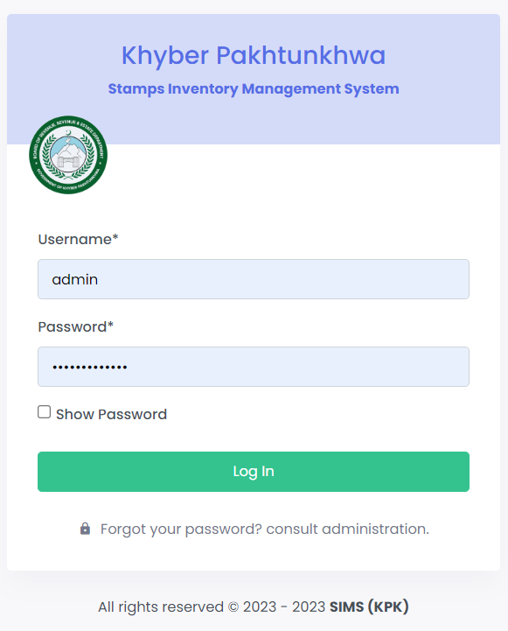

**3. DASHBOARD:**

- Upon successful login, you will be directed to the system dashboard.

- The dashboard provides an overview of key statistics and data related to stock in, stock out, transfer requests, and other relevant information.

- Use the dashboard to gain insights into the current status of stamp papers in your treasury office.

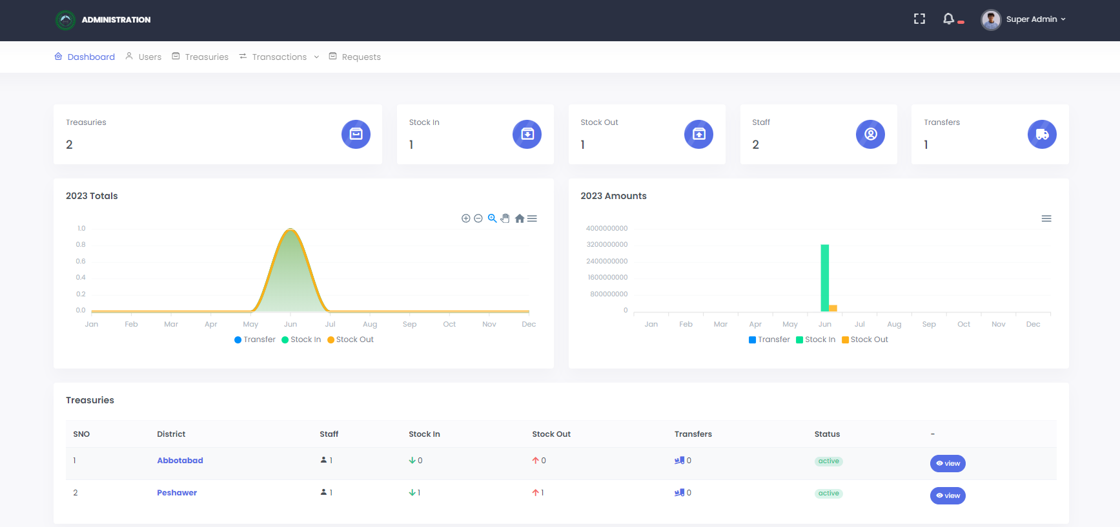

**4. TREASURIES:**

- Navigate to the "Treasuries" section to view a list of all treasury offices.

- The list displays important details such as treasury office name, district, staff count, stock in, stock out, transfers, and status.

- Click on a treasury office to view detailed information about its stock and transactions.

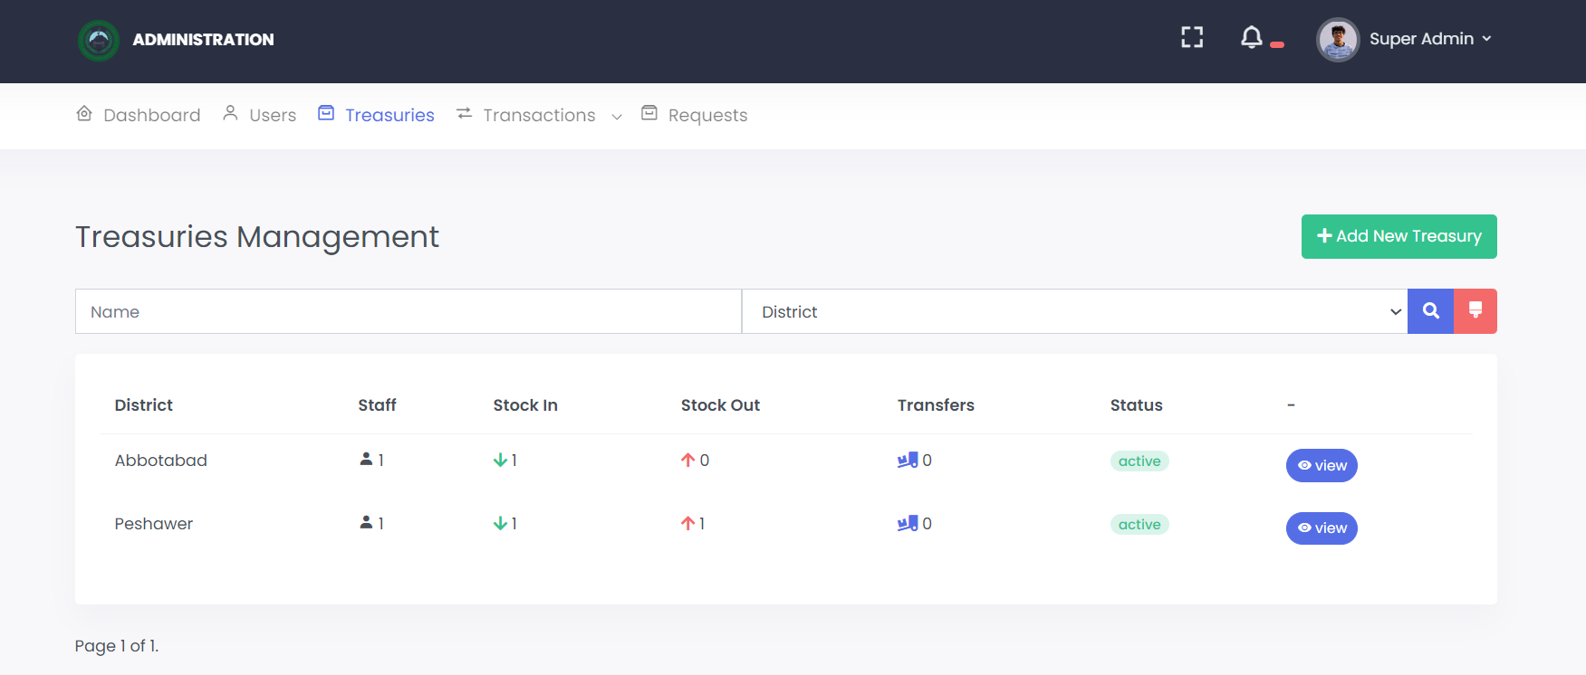

-Admin can add new treasury just by clicking “Add New Treasury”

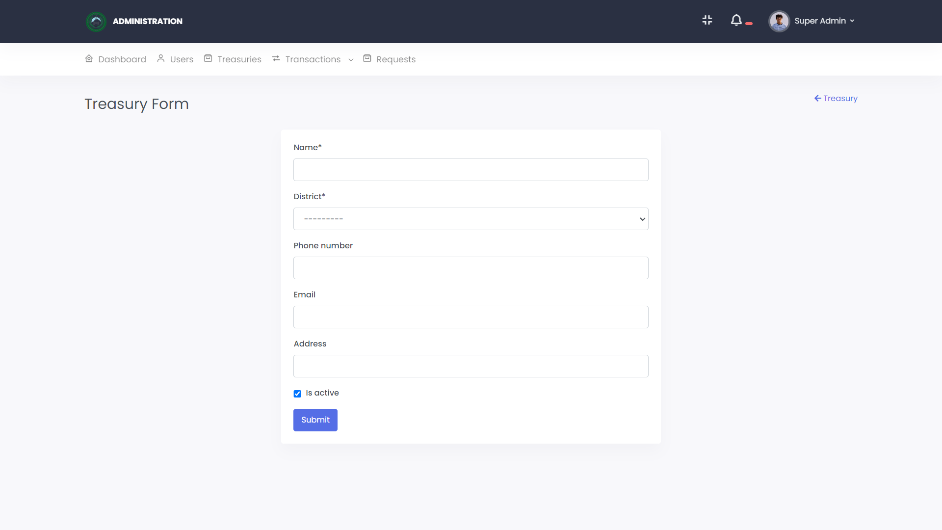

**5. TRANSACTIONS:**

- In the "Transactions" section, you can perform various actions related to stamp paper management.

**- Stock In:** Use this option to record the receipt of new stamp papers into the system. Enter the necessary details, such as the treasury office, quantity received, and other relevant information.

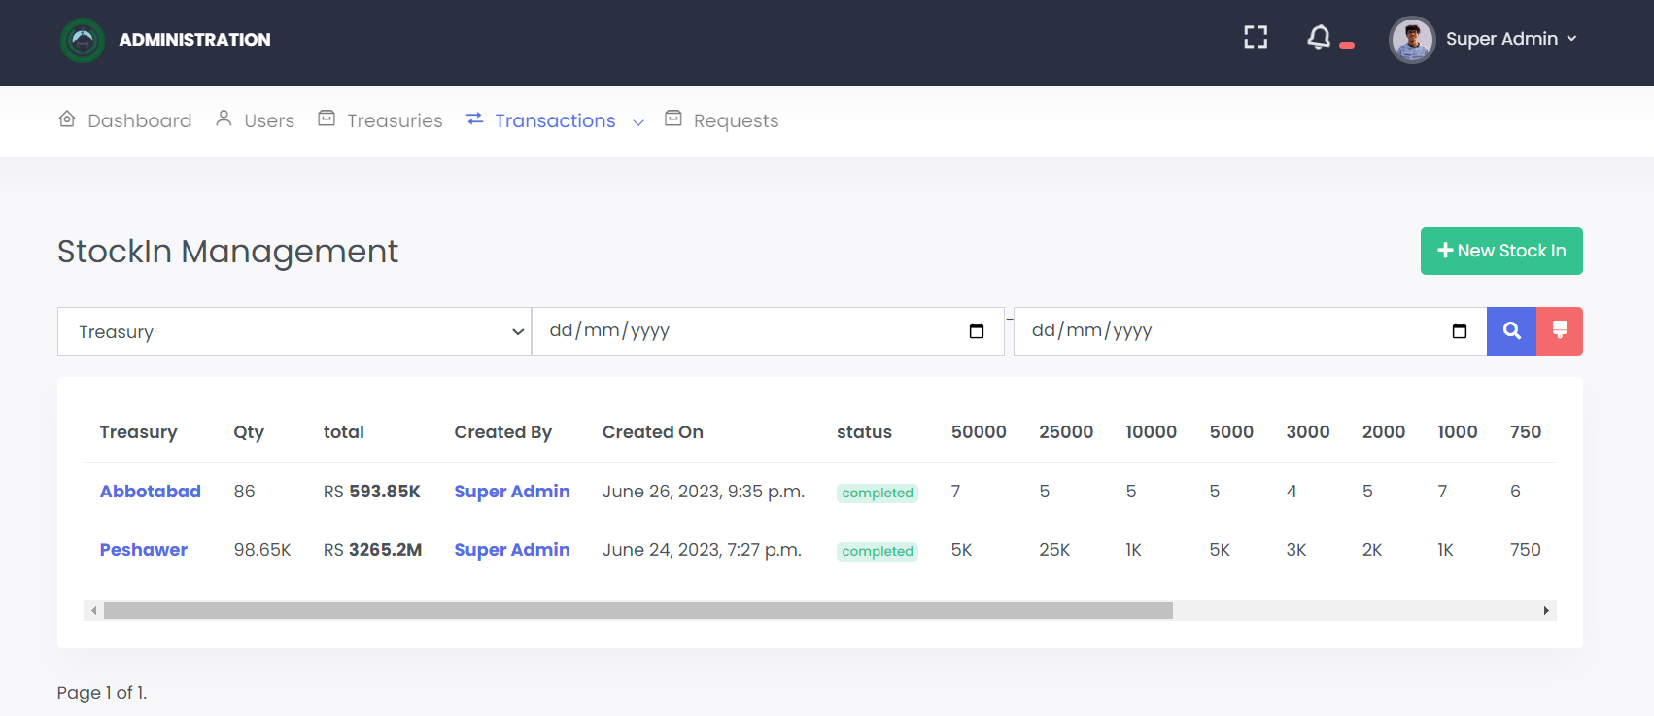

- In the "Stock IN" section, you can add new stock just by clicking “ New Stock In”

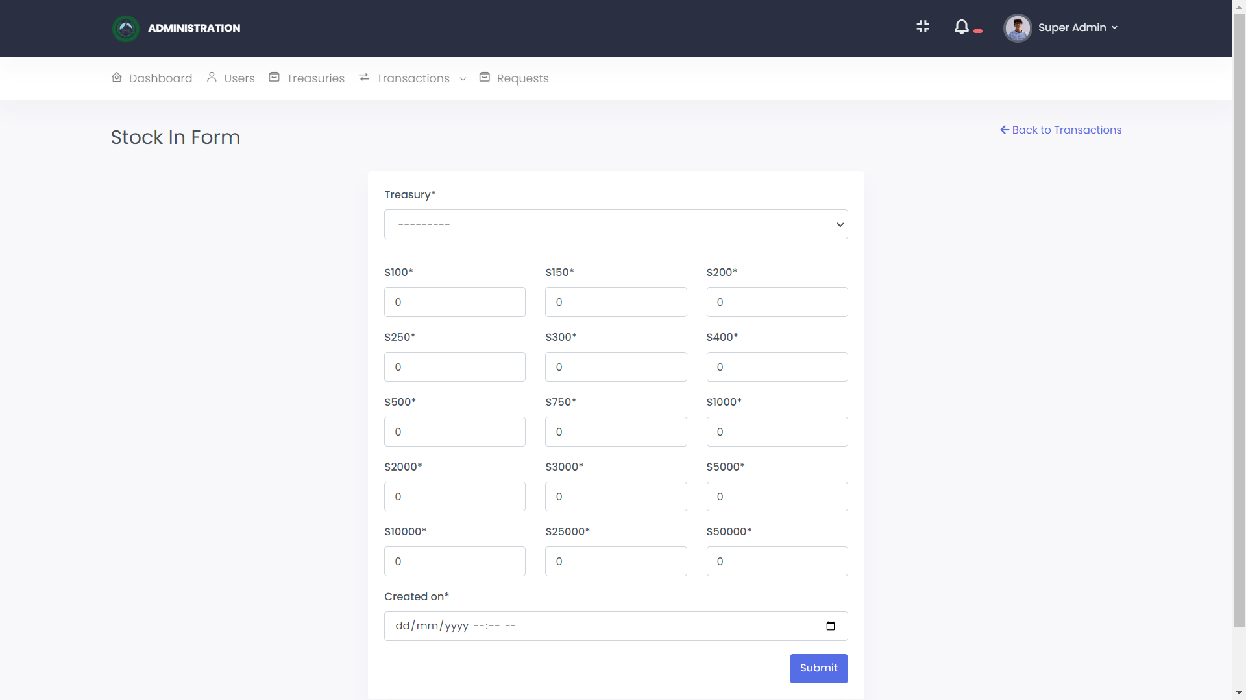

**- Stock Out:** Use this option to record the issuance of stamp papers from the treasury office. Specify the details, including the treasury office, quantity issued, and purpose.

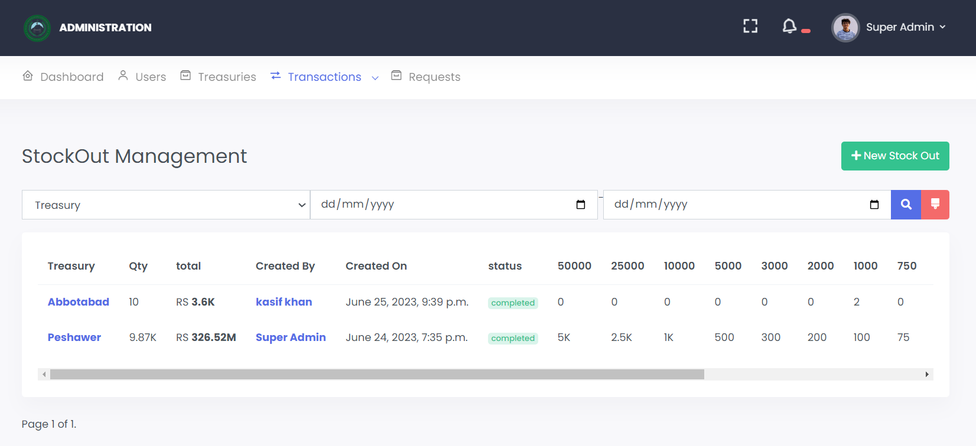

- In the "Stock OUT" section, you can remove stock data just by clicking “ New Stock out”

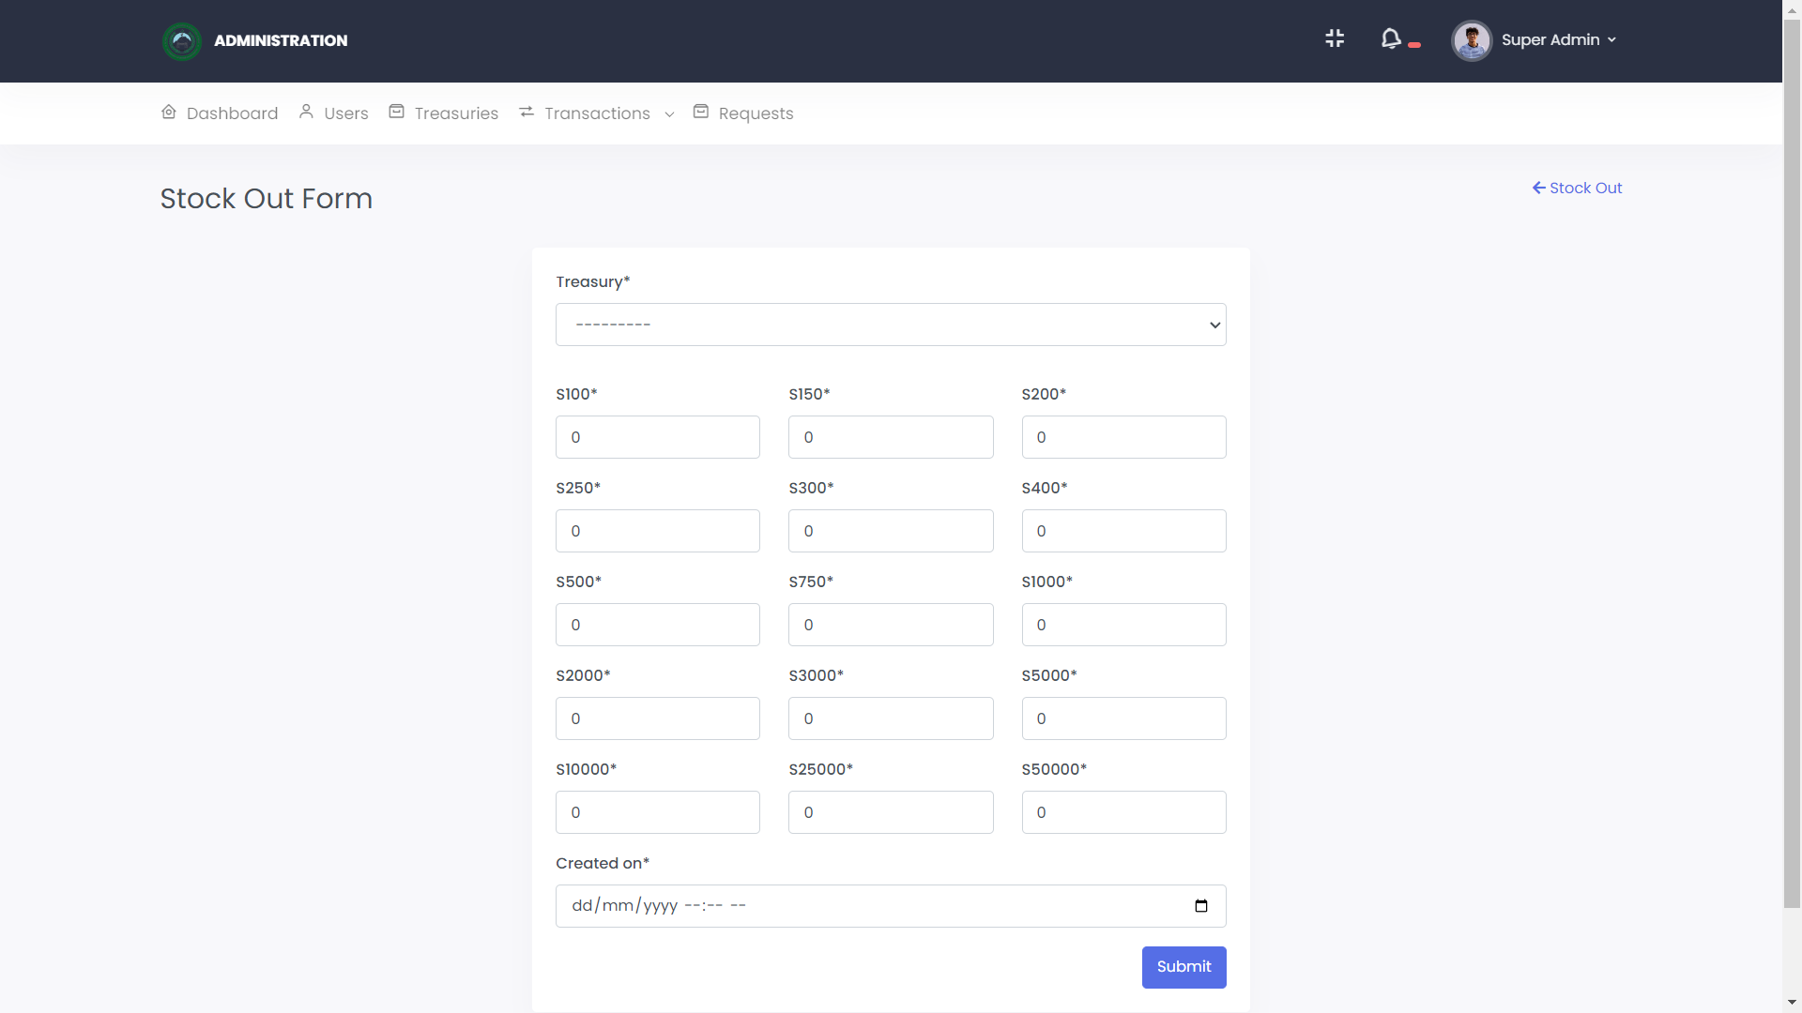

**- Transfer:** If there is a need to transfer stamp papers between treasury offices, use this option to initiate the transfer request. Provide the source and destination treasury offices, along with the quantity to be transferred.

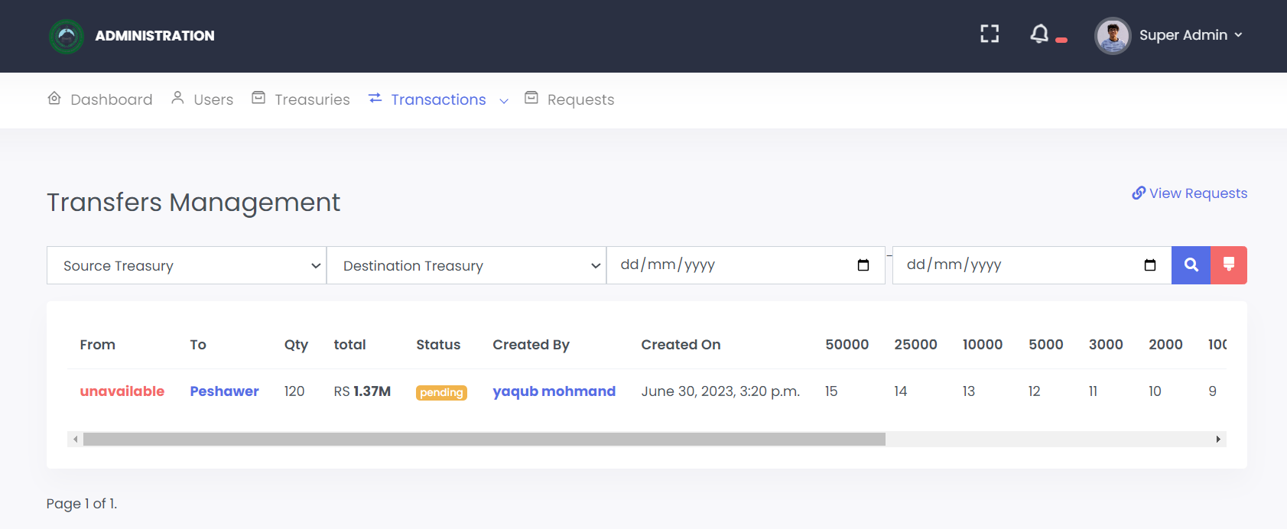

In the Transfer section you can view the whole details of transferred request

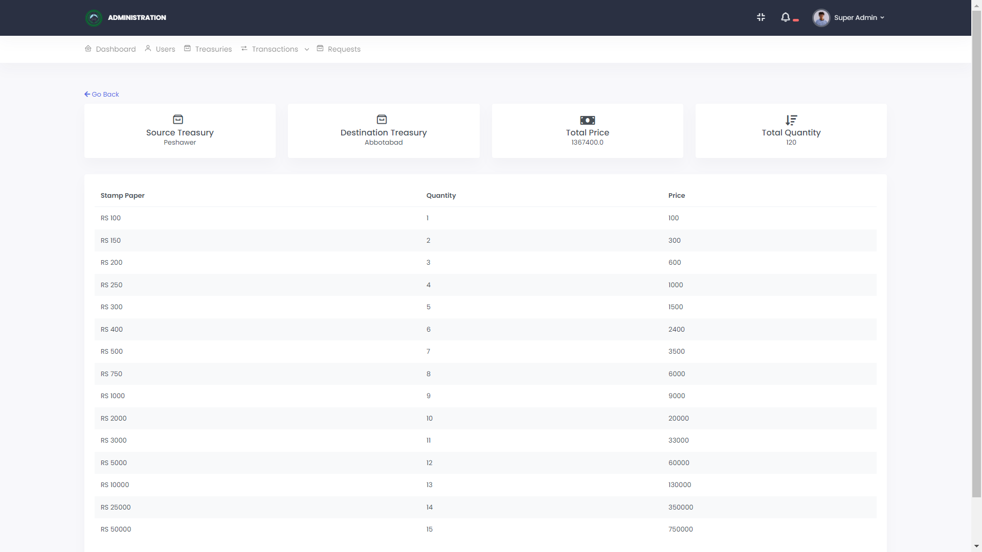

**6. REQUESTS:**

- Treasury members can request additional stamp papers for their respective offices.

- Access the "Requests" section to create a request for more stamp papers.

- Provide the necessary information, including the treasury office, date and time of the request, and the quantity of stamp papers needed.

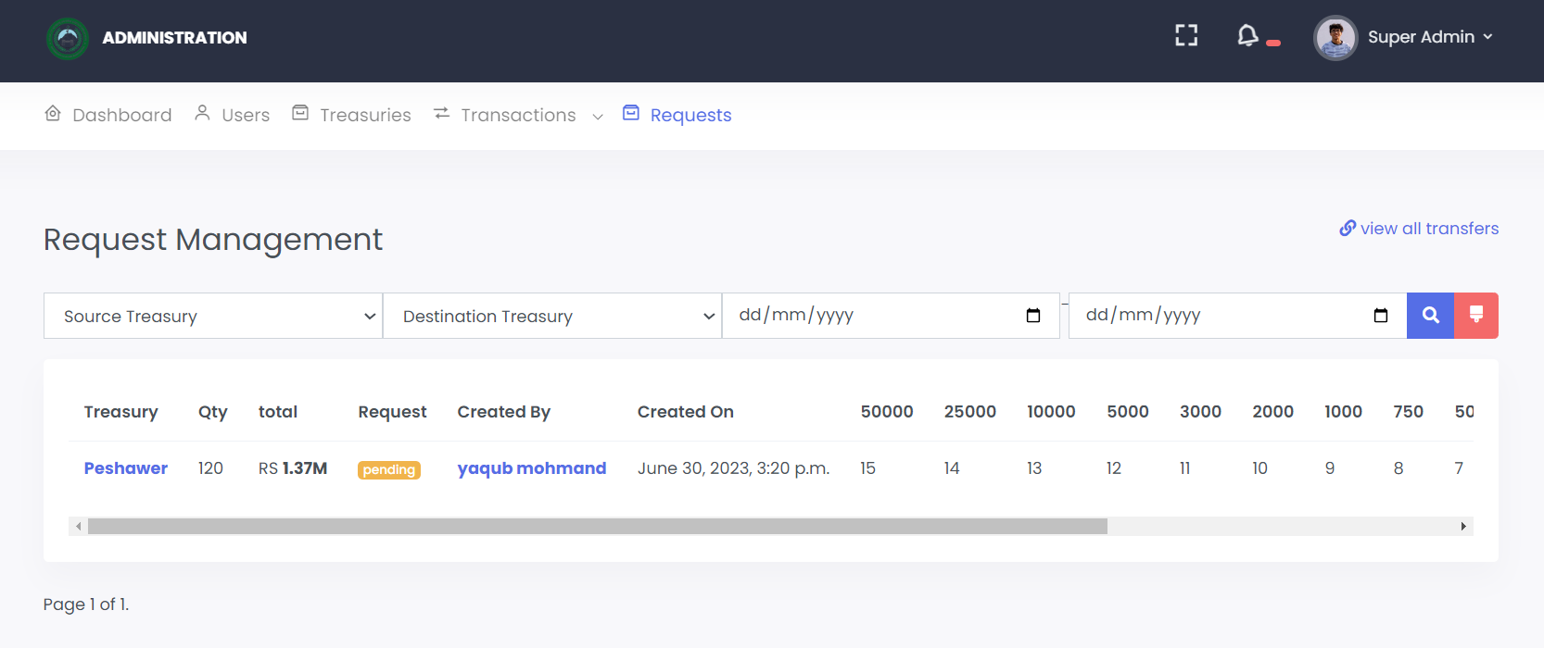

In the Transfer section you can view the whole details of transferred request

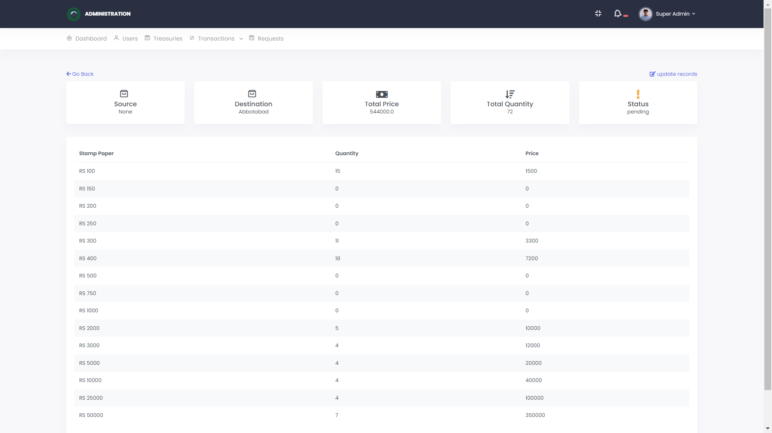

-Super Admin can change the status of request, by accepting or rejecting through form by clicking “update records”.

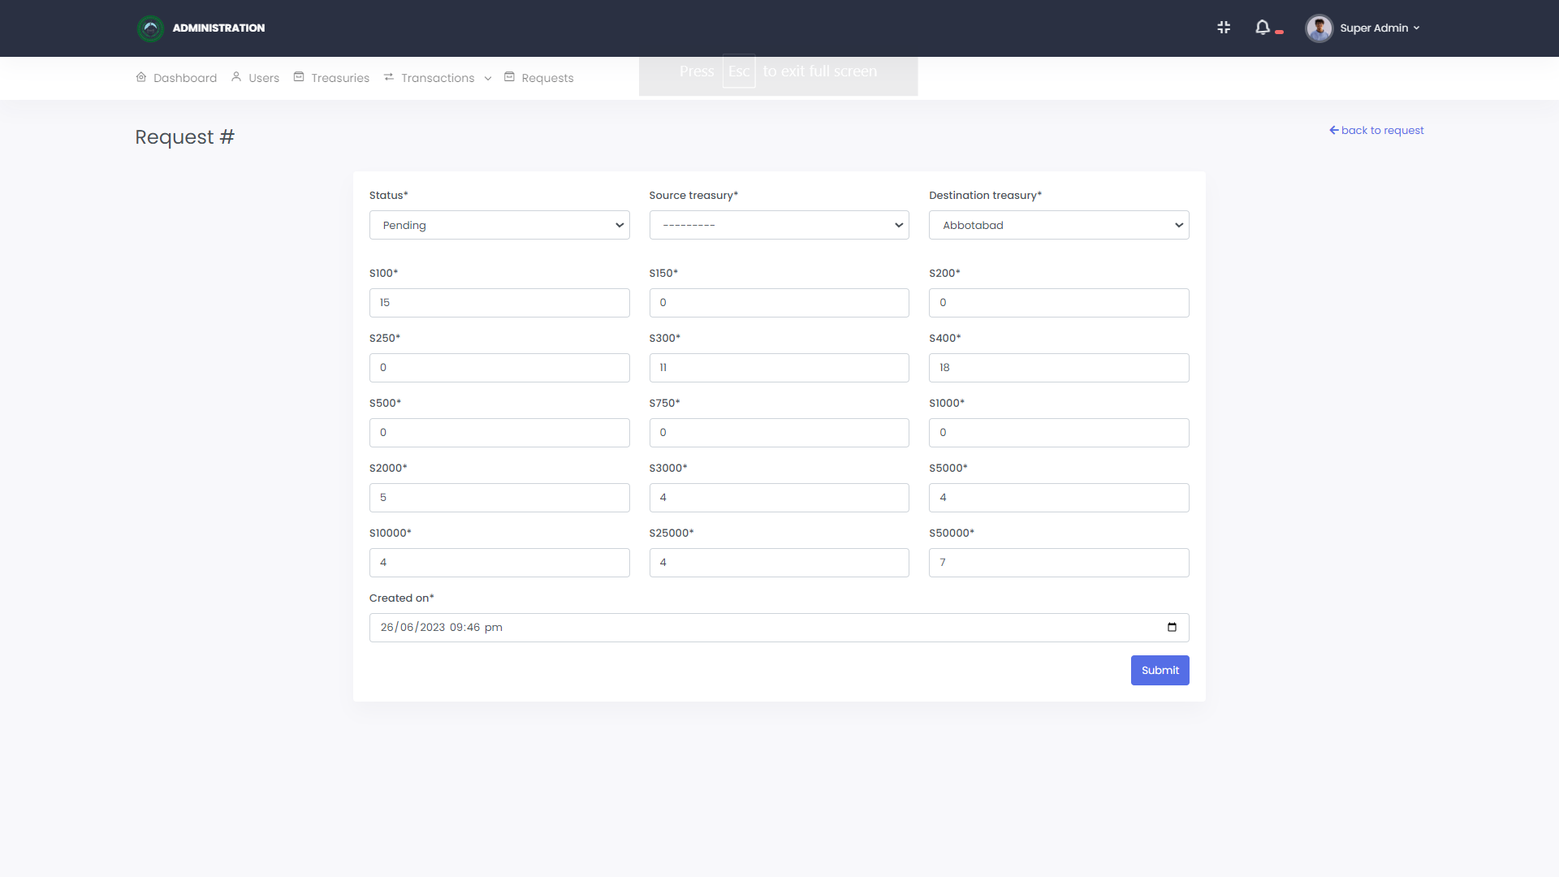

**7. USER ACCOUNT MANAGEMENT:**

- Update your account information, such as name, contact details, and password, by accessing the user profile section.

- If you encounter any issues or need assistance, there should be a contact or support option available. Reach out to the designated support channels for help.

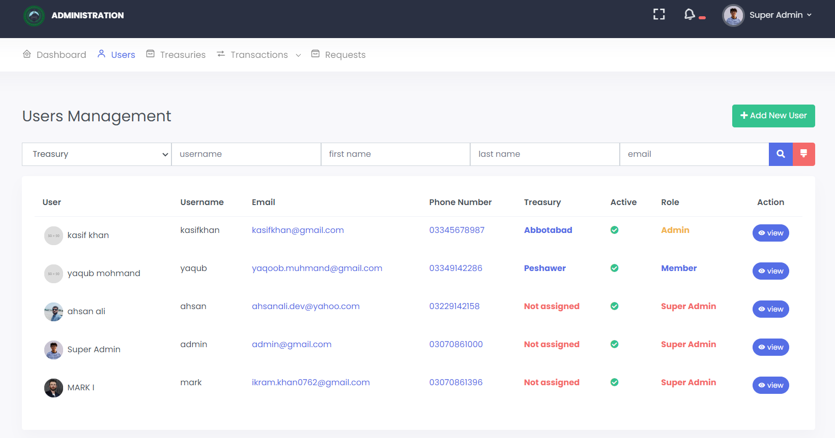

-Super Admin can create staff profile and can assign login credentials to staff by clicking and submitting the form.

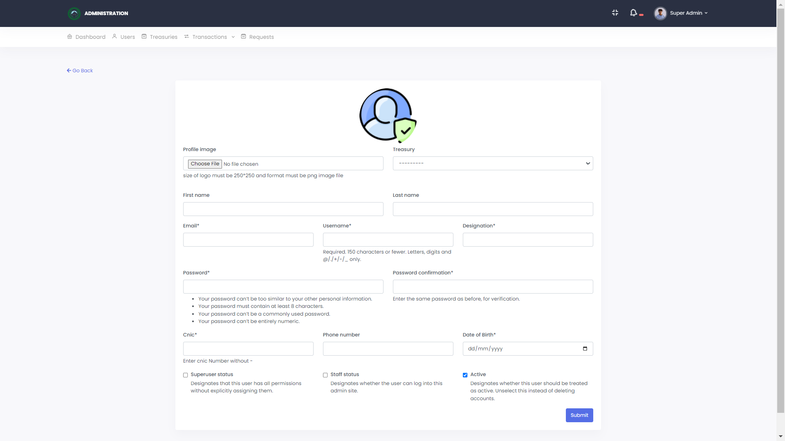

**8. REPORTING**

The Reporting System allows users to download reports on stock in, stock out, treasury, and available stamp papers amounts. These reports provide a comprehensive overview of stamp inventory movements, treasury balances, and the current availability of stamp papers.

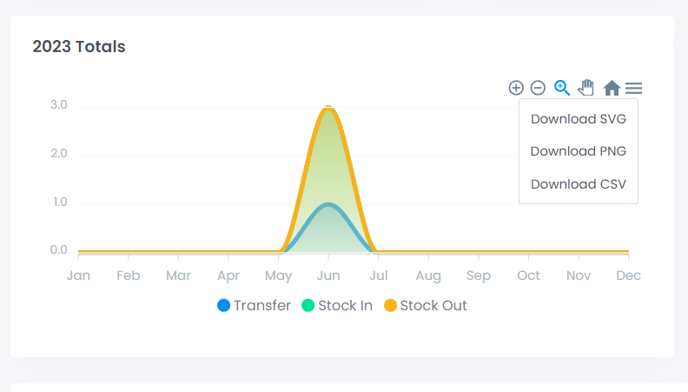

You can Download CSV, PNG AND SVG files of reports.

|  |  |  |  |
| --- | --- | --- | --- |
| **CATEGORY** | **TRANSFER** | **STOCK IN** | **STOCK OUT** |
| **JAN** | 0 | 0 | 0 |
| **FEB** | 0 | 0 | 0 |
| **MAR** | 0 | 0 | 0 |
| **APR** | 0 | 0 | 0 |
| **MAY** | 0 | 0 | 0 |
| **JUN** | 2 | 3 | 3 |
| **JUL** | 0 | 0 | 0 |
| **AUG** | 0 | 0 | 0 |
| **SEP** | 0 | 0 | 0 |
| **OCT** | 0 | 0 | 0 |
| **NOV** | 0 | 0 | 0 |
| **DEC** | 0 | 0 | 0 |

**9. LOGGING OUT:**

- To log out of the system, click on the "Logout" or "Sign Out" option located in the user menu.

- It is essential to log out of the system when you have finished using it, especially on shared or public devices.

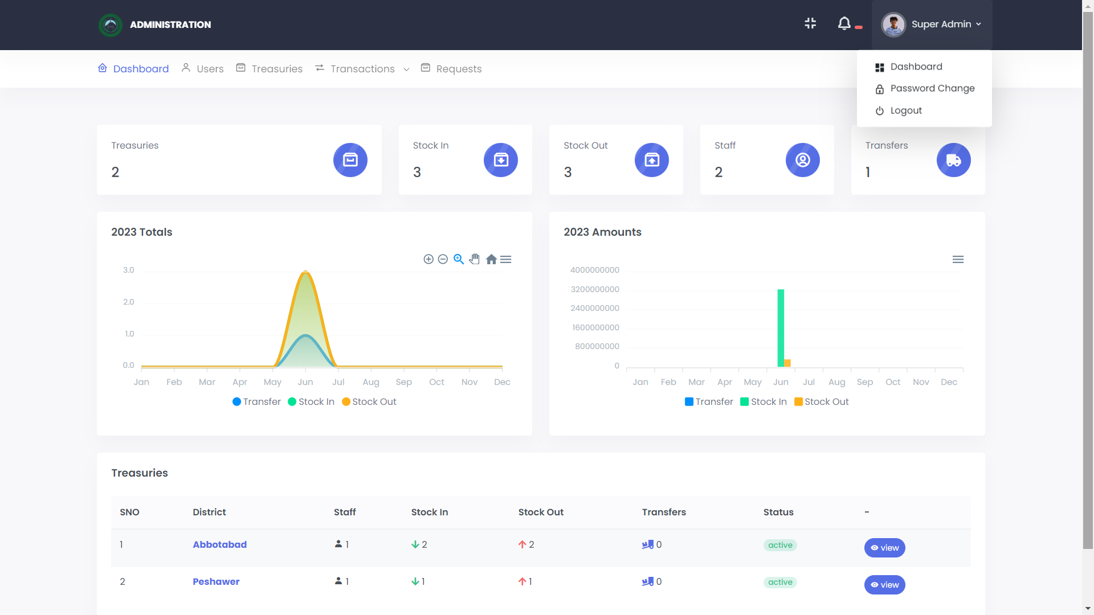

**STAFF PORTAL**

**1. SYSTEM ACCESS AND LOGIN:**

- Open a web browser and enter the system's URL.

- On the login page, enter your credentials (username and password) provided by the system administrator.

- Click the "Login" button to access the system.

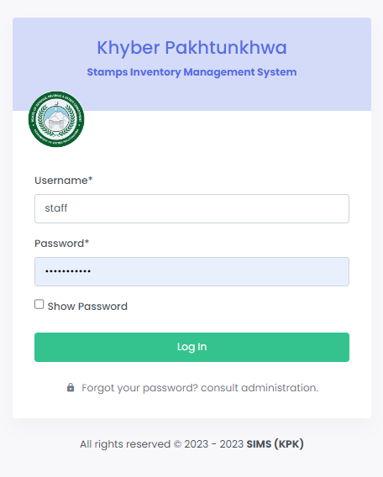

**2. DASHBOARD:**

- Upon successful login, you will be directed to the system dashboard.

- The dashboard provides an overview of key statistics and data related to stock in, stock out, transfer requests, and other relevant information.

- Use the dashboard to gain insights into the current status of stamp papers available in your treasury office.

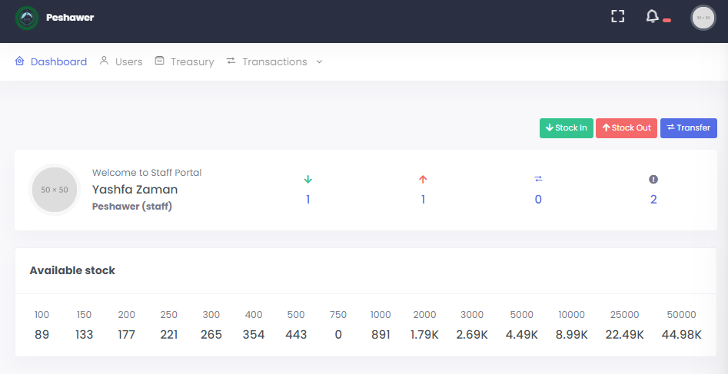

**3. TREASURIES:**

- The list displays important details such as treasury office name, district, staff count, stock in, stock out, transfers, and status.

- Click on a treasury office to view detailed information about its stock and transactions.

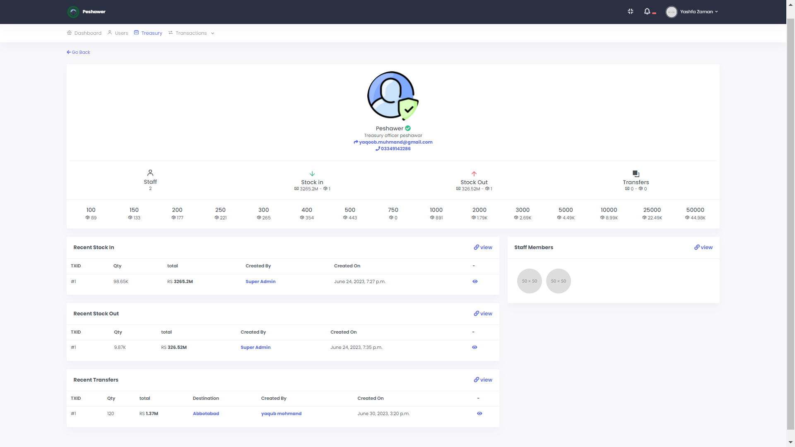

**4. TRANSACTIONS:**

- In the "Transactions" section, you can perform various actions related to stamp paper management.

**- Stock In:** Use this option to record the receipt of new stamp papers into the system. Enter the necessary details, such as the treasury office, quantity received, and other relevant information.

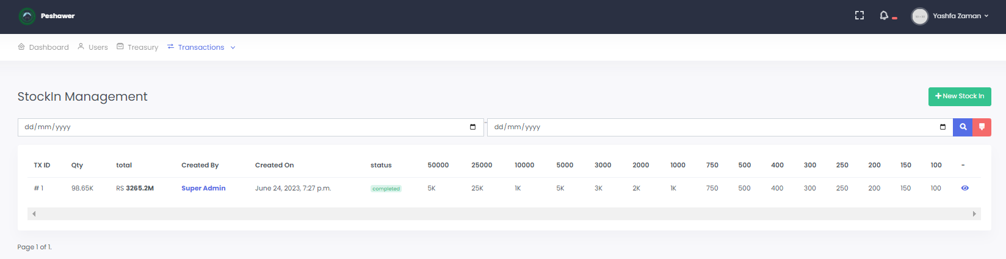

- In the "Stock IN" section, you can add new stock just by clicking “New Stock In”



**- Stock Out:** Use this option to record the issuance of stamp papers from the treasury office. Specify the details, including the treasury office, quantity issued, and purpose.

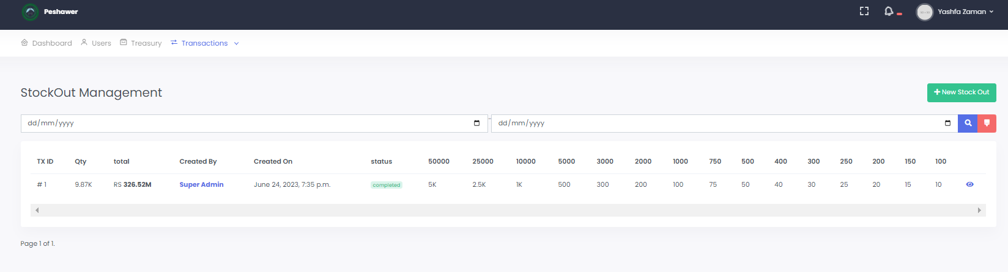

- In the "Stock OUT" section, you can remove stock data just by clicking “ New Stock out”



**5. REQUESTS:**

- Treasury members can request additional stamp papers for their respective offices.

- Access the "Requests" section to create a request for more stamp papers.

- Provide the necessary information, including the treasury office, date and time of the request, and the quantity of stamp papers needed.

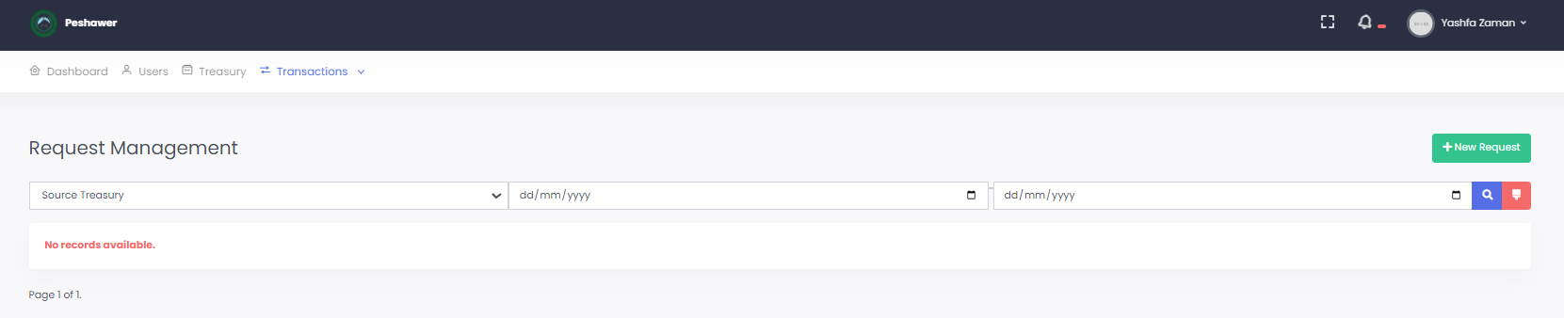

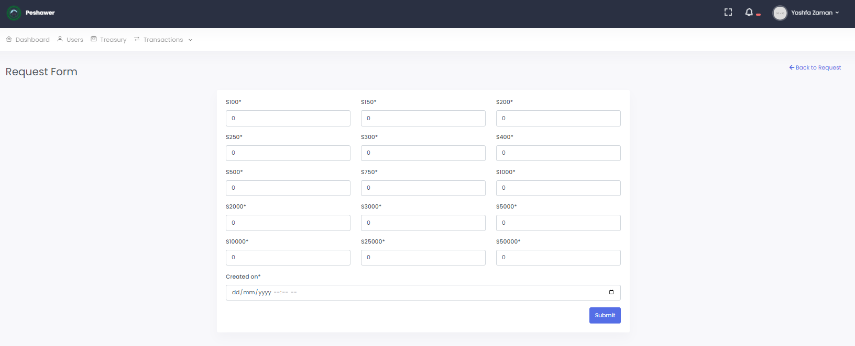

**6. USER ACCOUNT**

-Staff can just view the fellow members.

